**RUSLE2 Definitions**

**RUSLE2** uses a specific set of definitions, partly because the disciplines involved in soil erosion have not developed a common set of definitions. Observance of RUSLE2 definitions is required to obtain proper erosion estimates from RUSLE2 and to make the proper interpretation of those estimates.

**Overland-Flow Path**

The basic computational unit in RUSLE2 is an **overland**-**flowpath**. The overland-flow path used in RUSLE2 is the path that runoff follows from the origin of overland flow to the point where it enters a **concentrated flow area**, defined as a channel. The topographic information entered into RUSLE2 by the user for a specific site describes the slope steepness along this path.

**Basic RUSLE2 Erosion Variables**

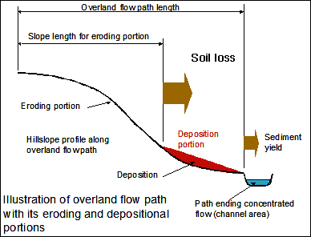

RUSLE2 estimates **average annual soil loss** from the **eroding portion** of the overland-flow path, **deposition** on the **depositional portion** of the path, and **sedimentload** along the overland flow path. **Sediment yield** (**delivery**) is the sediment load at the end of the overland flow path, at the outlet of terrace/diversion channels, or discharged from sediment basins that are considered in the overland flow path **(profile) r**epresentation used in a particular RUSLE2 computation. These quantities are expressed in units of mass per unit area per year.

**This sediment yield is for a site only if the RUSLE2 flow path happens to end at the site boundary.**

**Detachment** is the separation of soil particles from the soil mass. Net detachment adds sediment to the sediment load and causes sediment load to increase in a downslope direction. Deposition is the transfer of sediment from the sediment load back to the soil mass. **Local deposition** is the deposition of sediment very near to the point where the sediment was detached. Deposition of sediment eroded from soil clods in nearby depressions formed by the clods is an example of local deposition. **Remote deposition**is the deposition of sediment far from its point of origin such as deposition in a terrace channel or on the toe of a concave slope.

**Main RUSLE2 Outputs**

RUSLE2 displays the four output values of: soil loss from the eroding portion of the slope, detachment for the entire overland flow path, conservation planning soil loss, and sediment delivery (yield). **Soil loss**has a specific meaning. Soil loss is the net loss of sediment from the eroding portion of the overland-flow path. This value is used in **conservation planning**to select cover-management and support practices to control soil loss to a value less than **soil loss tolerance** or some other conservation planning criteria. **Detachment** is the total sediment production for the overland flow path length represented in a RUSLE2 computation. **Sediment delivery (yield)** is the amount of sediment leaving the flow path represented in a RUSLE2 computation. **Total deposition** for the overland-flow path, which is not displayed, is the differences between total detachment (sediment production) and sediment yield. **Conservation planning soil loss** gives partial credit to remote deposition depending on where the deposition occurs along the overland-flow path. RUSLE2 gives very little credit as “**soil saved**” for deposition that occurs near the end of the overland-flow path. Conservation planning soil loss is generally less than total detachment (sediment production) and greater than sediment yield. Full credit is taken for local deposition as soil saved.

**Topographic Descriptions**

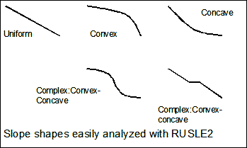

RUSLE2 can be applied to the many illustrated profile shapes that occur on both natural and constructed hillslopes. The **USLE slope length** definition was that deposition ended the slope length. However, if the overland flow continued across the depositional area, the slope length for the lower portion of the hillslope did not begin where deposition ended but began at the top of the hillslope where runoff began. The **complex: concave-convex** hillslope illustrates such a profile. The USLE cannot be easily applied to this slope shape. Rather than use the traditional USLE slope-length definition, RUSLE2 uses an overland-flow path-length definition. The RUSLE2 overland flow path length is the distance from the origin of overland flow to where the flow enters a concentrated flow area like an ephemeral gully or a terrace channel. RUSLE2 is very easy to apply to this slope shape and requires no special considerations for slope length like the USLE.

However, RUSLE2 can also be applied to only the eroding portion of the slope to make USLE compatible soil loss estimates. In this application, the USLE slope length can be used in RUSLE2 as the distance from the origin of overland flow to the point where deposition begins on concave slopes or to a concentrated flow channel.

The recommended RUSLE2 approach is to represent the entire overland-flow path from origin of the overland flow to a concentrated flow channel. RUSLE2 automatically determines where deposition occurs as a part of its computations. RUSLE2 computes and displays the soil loss on the eroding portion of the overland-flow path, the deposition on the depositional portion of the overland-flow path, and sediment yield from the overland-flow path without any additional consideration. RUSLE2 uses the hillslope profile description entered by the user to make the appropriate computations. This application illustrates the increased power of RUSLE2 over the USLE.

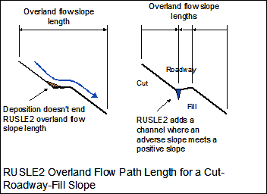

A special and easy application of RUSLE2 is the cut-roadway-fill slope. The first analysis might be to assume an outward sloping roadway. In that case, the overland flow path is from the top of the cut slope to the bottom of the fill slope. If the slope of the roadway is back into the hillslope (i.e., the roadway has an adverse slope), a negative steepness is entered for the roadway and RUSLE2 automatically divides the slope into the proper overland flow path lengths.

RUSLE2 also computes the deposition that occurs in diversions and terrace channels that end an overland flow path. However, RUSLE2 does not compute the erosion that occurs in these channels if they are on a steep grade. RUSLE2 also computes deposition in small sediment basin type impoundments.

RUSLE2 computes the erosion rate (or deposition) for individual slope segments. These erosion (or deposition) values represent net sediment production (or deposition) within each segment. The ability to compute net sediment production along a slope is a very powerful RUSLE2 feature, especially for convex shaped slopes. Erosion rate at the end of a convex slope can be much greater than the average erosion rate for the entire slope.